**Project Pitch**

**Description:**

Project Romeo, from here on referred to by its working title of “Spark of Love” (SoL), is a brick puzzle game centered on romance. In the game, bricks of colored fireworks fall from the sky and it is the player’s job to organize them by color. The player must pile like color fireworks on top of and around one another before igniting them into a colorful display. Placing fireworks into quadrilateral shapes of 2x2 or more will result in a score multiplier and greater visual flair upon their launching. Alongside the fireworks, will fall colored torches which can only ignite like colored fireworks, and white torches which will light fireworks of any color. Landing a torch on our next to a like colored firework will ignite that firework and all fireworks of the same color touching it, which will in turn ignite the others touching it. Thus a chain reaction of that color firework appears and the player scores more points with a single torch. There are two modes of play. In “Quest for Love,” the player is trying to impress a nearby prince by igniting the largest and most impressive fireworks display possible. The goal of this mode, is to score a set amount of points each level, in order to progress to the next. In “Blazing Love,” the player is given an endless set of falling fireworks and play continues as long as the player wishes, or until the fireworks reach the top of the screen.

SoL is targeted at men and women between the ages of 14 to 60 who use their iPads as a recreational tools on occasion. The game will be free to play with short video advertisements between gameplay sessions, delivered at random intervals. The only purchasable option within the game is the ability to turn off ads for a onetime fee. We will be utilizing Game Center and iCloud for all account management.

**Game Features:**

* Fast and bright gameplay with a fantasy medieval aesthetic
* Free to play with 30s ads between gameplay sessions
* 2 Modes of play with achievements and leaderboards handled by Game Center

**Gameplay Examples:**

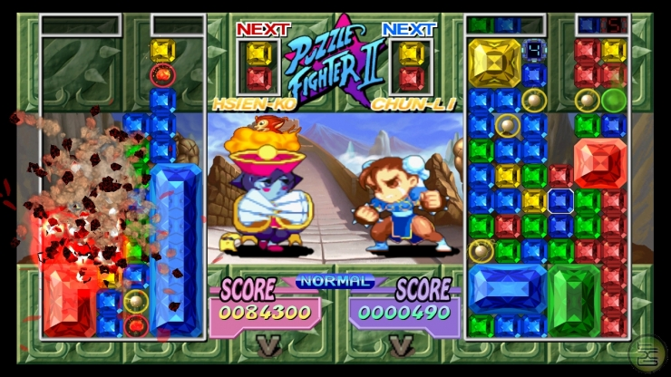 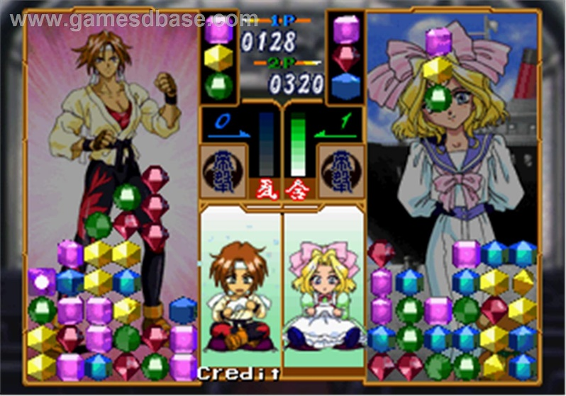

Super Puzzle Fighter 2

Hanagumi Taisen Columns

**Project Overview**

**Money**

Total Budget: $49 x 6 x 40 x 52 = **$611,520**

|  |  |  |
| --- | --- | --- |
| Expenditures | | |
| Expenditure Name | Cost | Total Remaining Budget |
| Emergency Fund | $50,000.00 | $611,520.00 |
| Mid-Level Artist (39 Weeks) | -$70,200.00 | $541,320.00 |
| College Hire Engineer | -$72,800.00 | $468,520.00 |
| College Hire QA (38 Weeks) | -$53,200.00 | $415,320.00 |
| College Hire Design | -$72,800.00 | $342,520.00 |
| College Hire UI/UX | -$72,800.00 | $269,720.00 |
| Mid-Level Project Lead | -$93,600.00 | $176,120.00 |
| Testing iPad Air 2 | $-546.40 x 4 = -2,185.62 | $173,936.38 |
| Unity Professional License | $75/month x 12 x 6 = -5,400.00 | $168,534.38 |
| iOS Developer Program | -$99.00 | $168,435.38 |
| Adobe Creative Cloud for Teams | $69.99 x 12 = -$839.88 | $167,595.50 |
| Audio Asset Budget | -$2,000 | $165,595.50 |
| GitHub Bronze Membership | $25/month x 12 = -$300 | $165,295.50 |
| Travel Budget | -$5,000 | $160,295.50 |
|  | Remaining Budget: | $160,295.50 |

**People**

Priority Hires:

1. Junior Engineer
2. Junior Designer
3. Junior UI/UX
4. Mid-Level Artist
5. Junior QA

Team Member Breakdown:

Junior Engineer

As we are creating a small tablet app with limited programming complexity, we will be well served by hiring an entry level engineer for the job. An engineer of this level should have no problem handling our programming and integration requirements without costing us too much money.

Cost: $72,800

Junior Designer

A junior level designer will serve us better than a mid-level or senior designer as they will require little cost while being able to handle the duties of designing the systems, gameplay, and feedback for the project.

Cost: $72,800

Junior UI/UX

A Junior UI/UX employee will be able to work well with the junior designer and cover all of our needs.

Cost: $72,800

Mid-Level Artist

A small app like SoL lives or dies by its art style so I am budgeting for a mid-level artist with more experience working on projects like ours. I have also budgeted for an additional 3 months of time to find an artist who suits our game’s style. This will also allow us to reduce the financial impact of hiring a mid-level employee.

Cost: $70,200

Junior QA

For QA, we will be hiring a junior QA tester to start about a month into development. This way, they will be able to get right to work as soon as they are hired. This will also provide fresh eyes on the project.

Cost: $53,200

Development Methodology:

Our methodology will be **Scrum**. This will allow us to work closely on a team and cross collaborate as needed while maintaining frequent team communication. This will be beneficial as we are a studio annex team who need to maintain a strong line of communication with one another. This methodology will also allow us to rapidly shift development if the need arises.

**Tech**

Launch Device: iOS iPad

Impact:

Engine – Unity 5

This engine has a proven track record of excellence on iOS and also allows us to transfer devices easily if the need arises as it functions well on most current devices.

Software – Adobe Creative Cloud

Creative cloud will allow us to create any 2D art assets we may require in house.

Software – GitHub

GitHub will allow our team to share our project easily with each other and with the main studio for a small fee.

Launch Service – iOS Developer Program

For a small fee, we will have a small amount of development support and be able to place our game on the app store once it is finished.

Device Testing – iPad Air 2

We will be purchasing four iPad Air 2s for development and testing. 3 of these will be used for daily development tasks while one is left on the sidelines for use if one of the others should break. There is space in the budget to purchase more if the need arises.

**Logistics**

Workspace – Studio Annex

As a team we will be together, though we will not have direct access to the main campus without having to travel. As a result, I have budgeted $5,000 for travel. While taking the whole team to the main campus should not cost very much, this large travel budget will allow us to travel longer distances if needed.

Meetings – Daily

As a small team, it will be beneficial for us to start each day with a brief meeting to discuss what each team member is working on that day, and how we can best aid one another. One meeting per week will be longer to allow for information relay with the main campus or talk about major shifts in development if required.

If main campus requires input on a meeting, we will video chat when possible, or travel to main campus if need be. Video calls would be the ideal, as it would be less distracting to our work flow.

Remote Access – Windows 10

Windows 10 has built in remote desktop capabilities. If the need arises, we can access our office systems remotely from any Windows 10 enabled device.

**Roadmap**

|  |  |  |
| --- | --- | --- |
| Month | Product Life Cycle | Core Tasks |
| January | Pre-production | Team Hiring  Software and Hardware Procurement  Begin Development Planning  Begin Setting up Core Systems |
| February | Pre-production | Finalize Development Planning  GDD Creation  Competitor Research |
| March | Pre-production | Finalize Development of Core Systems  Art and QA Hiring |
| April | Production/Development | Define Art Style, Concept Work  Gameplay Integration  Internal QA Testing  *PAX East (22-24) |
| May | Production/Development | Gameplay Development  Begin Gameplay Art Asset Creation  Internal QA Testing |
| June | Production/Development | Gameplay Development  Game Center Integration  Gameplay Art Asset Creation  iCloud Integration  Internal QA Testing  *E3 (14-16) |
| July | Production/Development | Gameplay Art Asset Creation  Achievement Development  Gameplay Development  Begin UI Art Asset Creation  Internal QA Testing |
| August | Production/Development | Gameplay Development  UI Art Asset Creation  UX Emphasis  External QA Testing  *PAX Prime (End of Month) |
| September | Production/Development | Gameplay Development  Monetization Implementation  UX Emphasis  External QA Testing  *TGS |
| October | Production/Development | Launch Prep  UX Emphasis  External QA Testing |
| November | Launch/Live | Final Bug Squashing  Submit to Apple for Certification (11/15)  Post Launch Support  External QA Testing  *PAX Australia |
| December | Launch/Live | Post Launch Support  External QA Testing |

*Optional Events